**Need an image, project name and a case study for at-least 3 projects the more the better thou**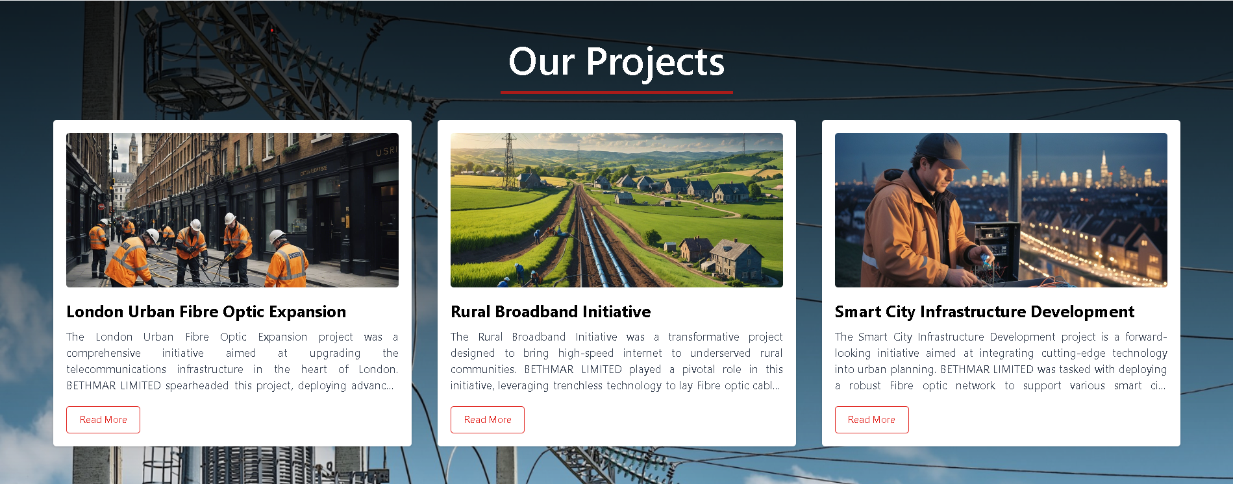

**Review this content and image. Will be helpful if I can get content and image too**

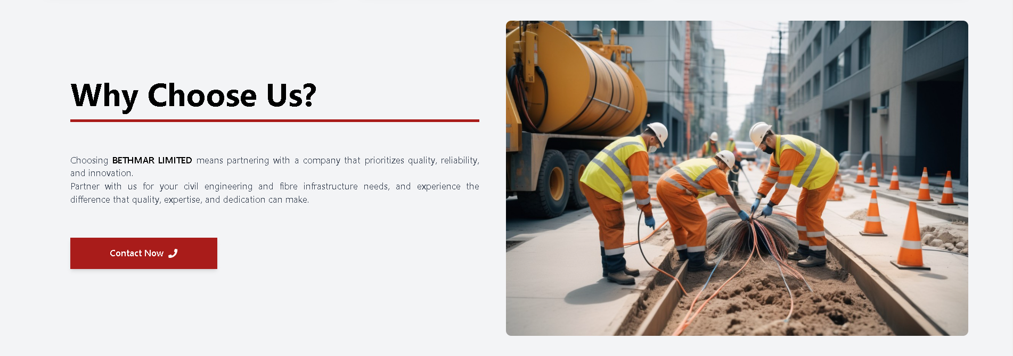

**Need the details for Achievements and a quote to go with contact us  
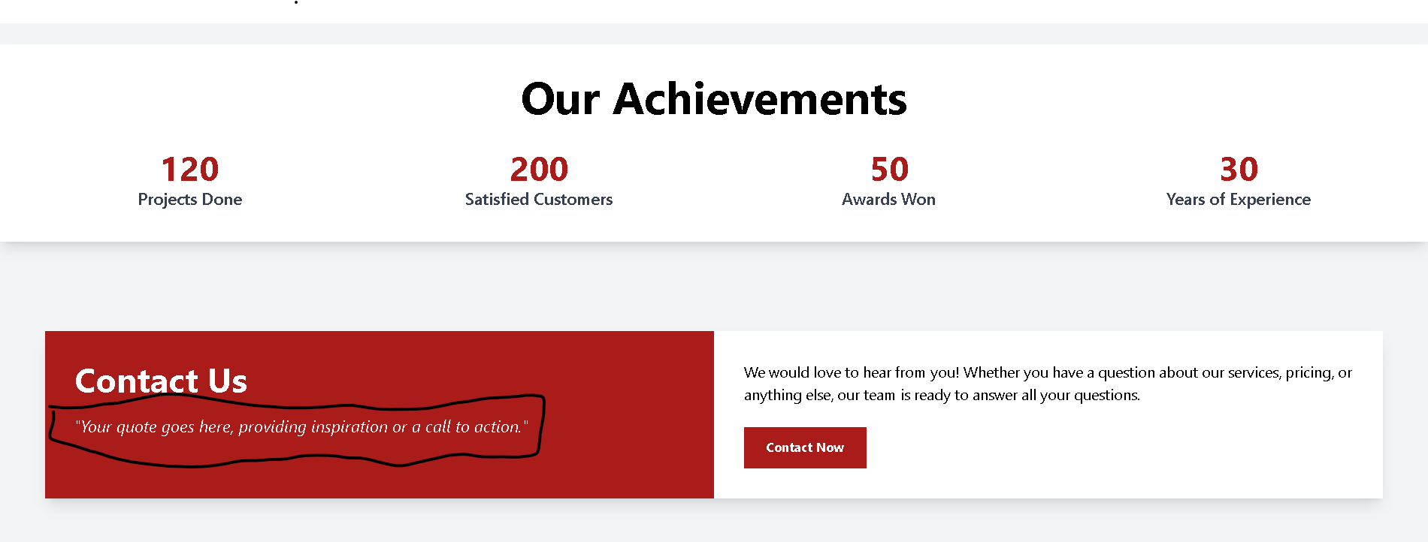**

**Need higher resolution images for banner 16:9 (landscape preferably)  
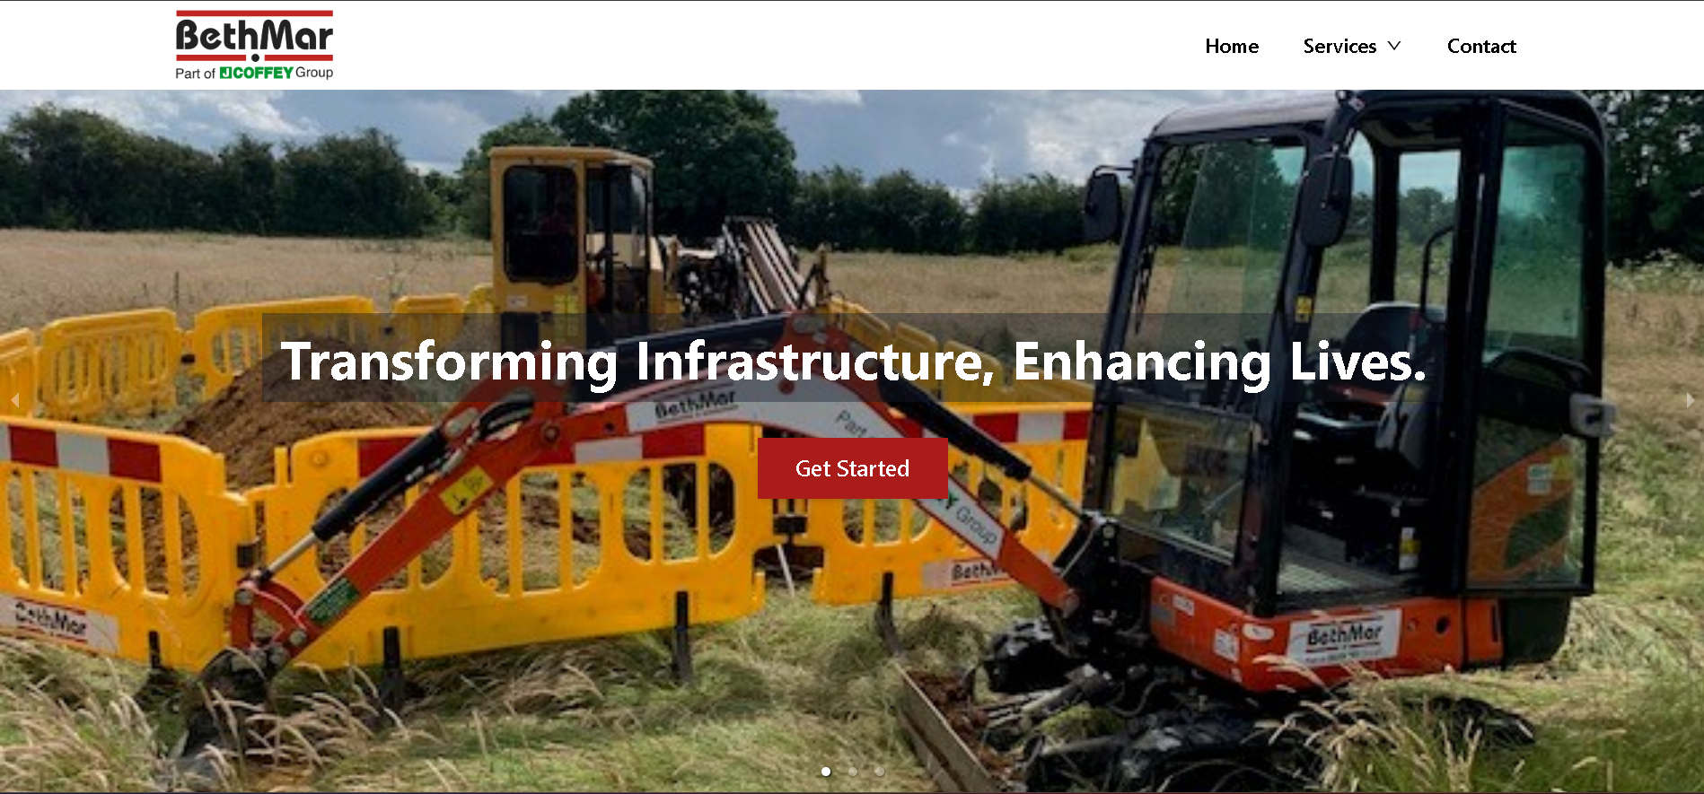**

**Content required for each of the pages civil, fibre, design validation, traffic management and reinstatement**

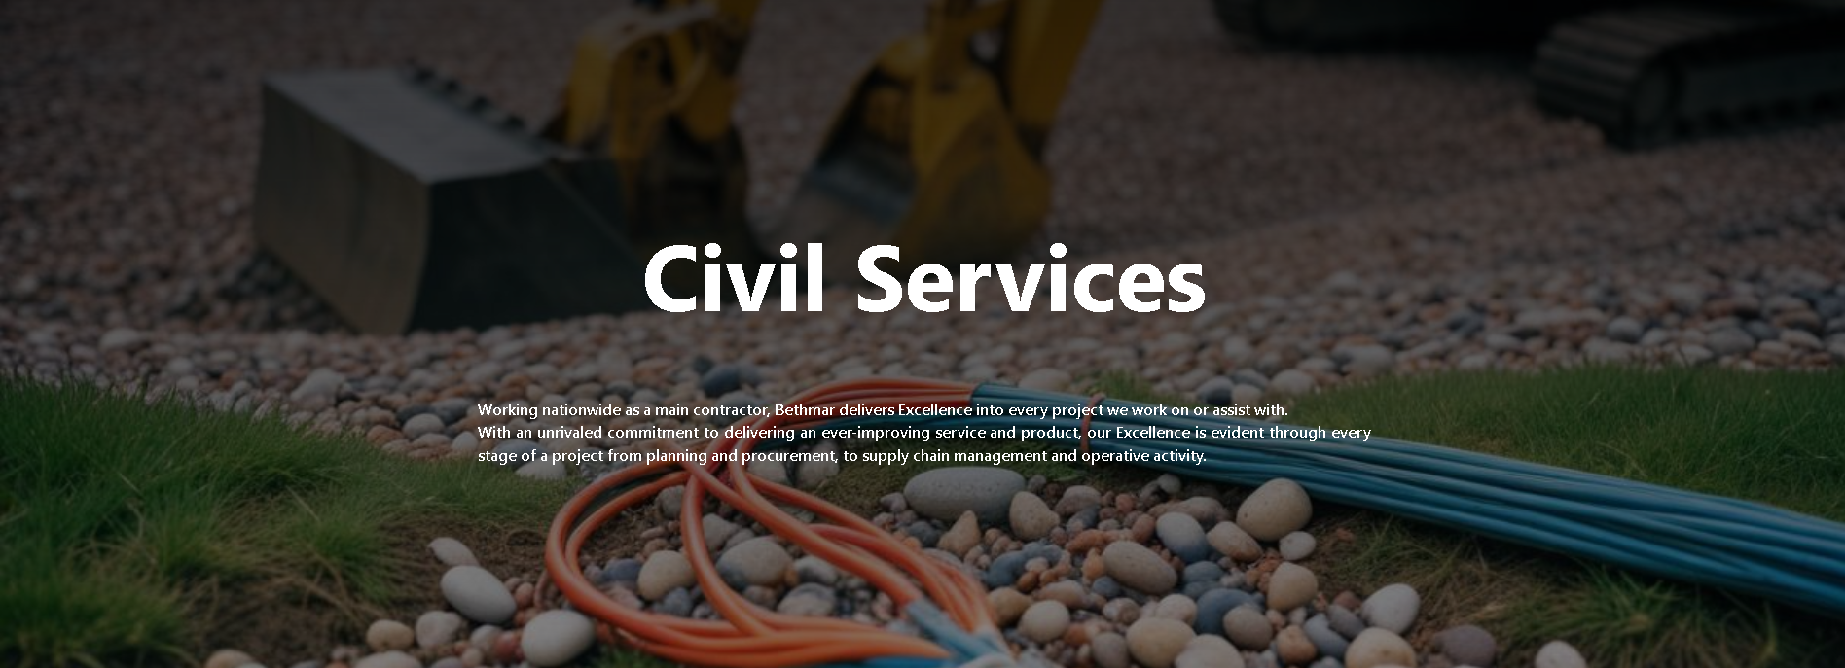

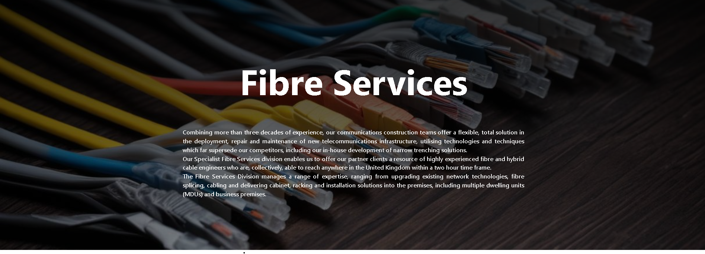

**Need Content and images for these cards  
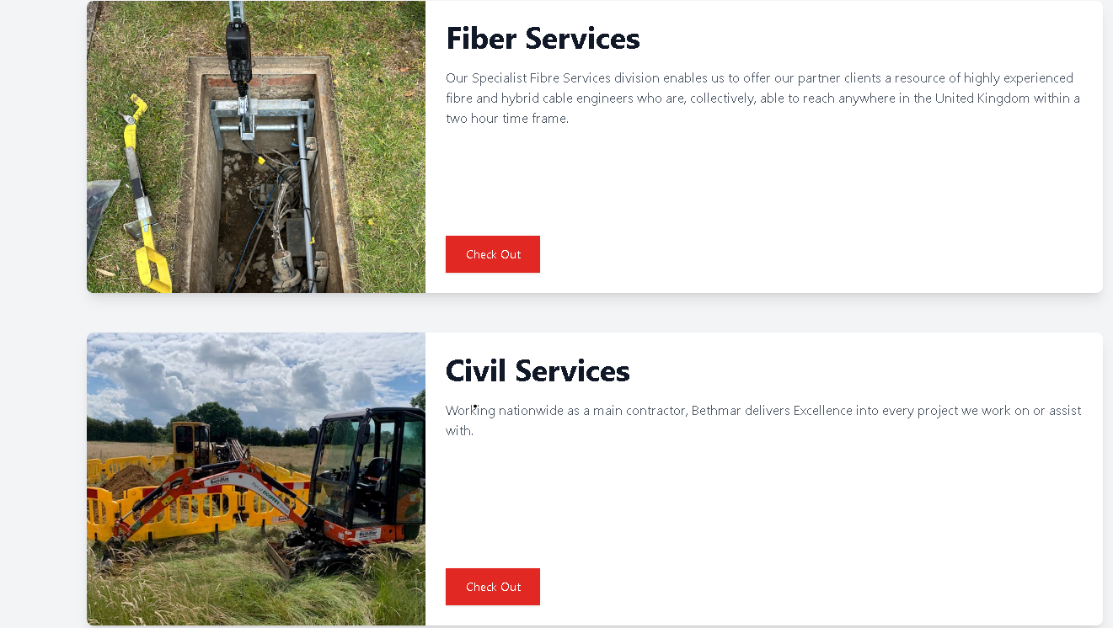**

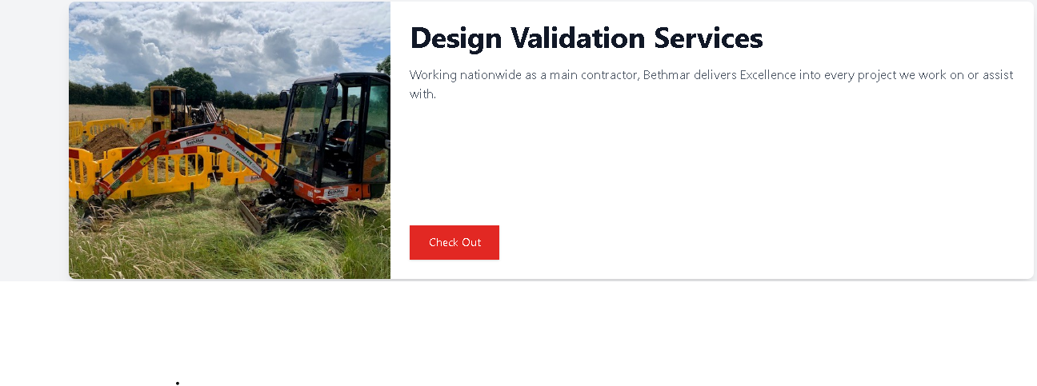

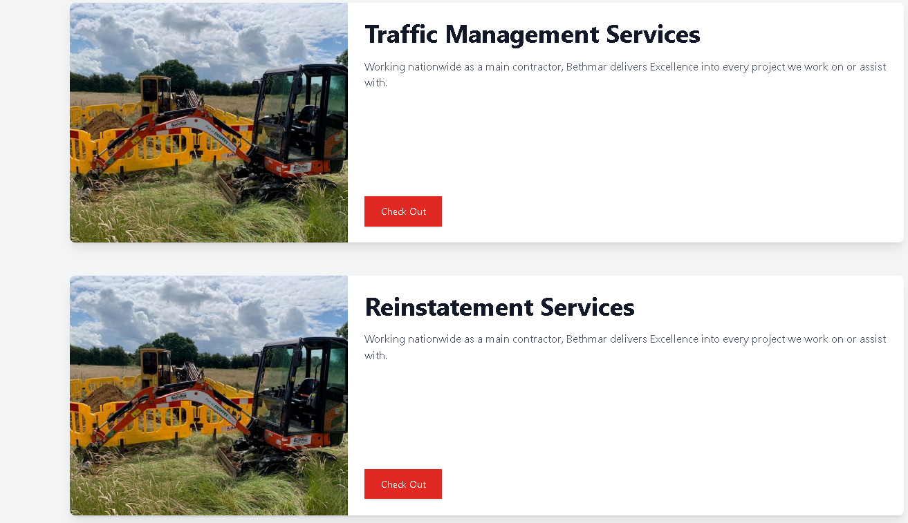

**I have fixed the header and made it black, the text now starts and ends at same point, put a bit of dark gradient behind OurProjects headings so that it is more visible.**